**Implement the MVC pattern in java**

Create a view as given below. Its having one label have some text. One button LoadData which reads the data from a text file and assigns that text to the label. Create one text area field which takes some input from the user and one WriteData Button. When user clicks on Write Data button , the text from the text area field written into another textFile.

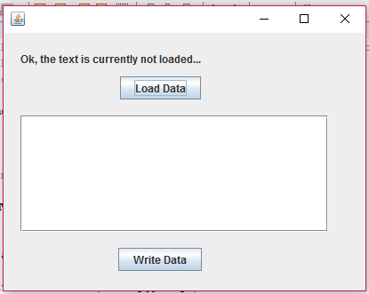

When I click on load data your view going to change like this

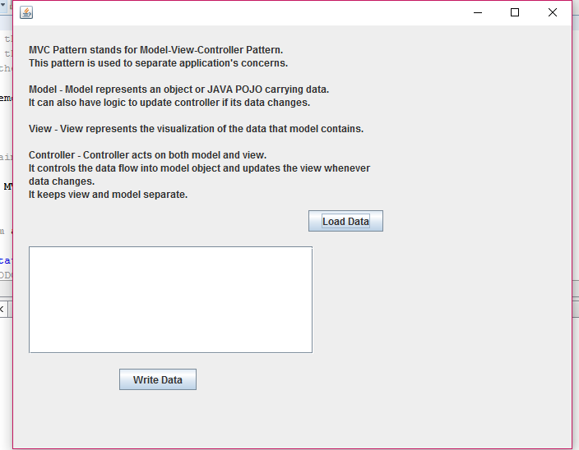

Next add some text in textarea field and click on write data button so text is going to store in one text file

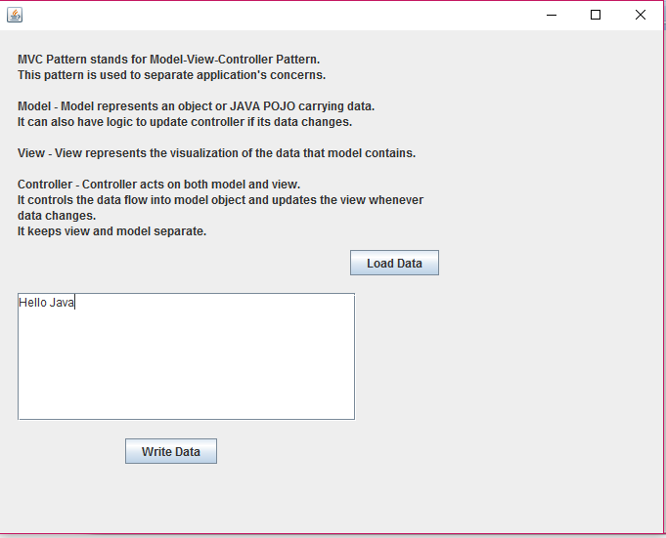

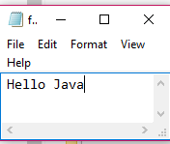s